http://www.spc.int/oceanfish/en/ofpsection/ema/biological-research/trophic-dynamic-sampling

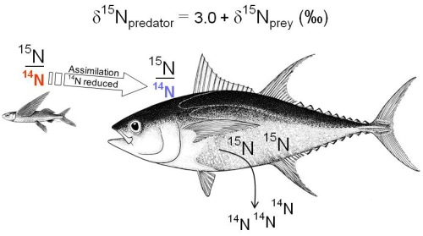  
The excretion rate of the lighter isotope (14N) is greater than that of the heavier isotope (15N) during metabolism inducing about 3‰ of accumulation per trophic level

15N

At each trophic level, an increase of ~3 units (expressed in stable isotope analysis as ‰ notation) has been observed in the isotope ratios (δ15N=15N/14N) of consumer’s tissues relative to their diet (Deniro and Epstein 1981. Geochim. Cosmochim. Acta 45:341-351). An important qualification is that the d15N value of a consumer is a function of both the trophic level of that consumer and the d15N at the base of the food web.

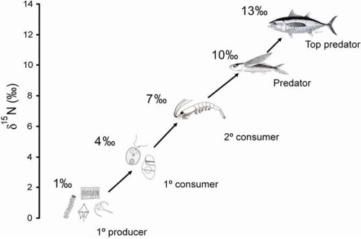  
Isotopic fractionation: lighter isotope is excreted in greater proportion than heavier isotope, leaving the animal enriched in 15N and 13C relative to its food source.“You are what you eat + 3.0‰” + 0.5‰ in δ 13C